Capstone Project-I Report
on
A Crowdsourced Civic Issue Reporting & Resolution System
submitted in partial fulfilment of the requirements for the award of the degree of

BACHELOR OF TECHNOLOGY
in
COMPUTER SCIENCE AND ENGINEERING



Submitted by  Harshita Singh (2K23CSUN01254)  Purab Bhatia (2K23CSUN01267)  Piyush Sharma (2K23CSUN01038)  Rajat Kar (2K23CSUN01044)  K. Shreeshanth (2K23CSUN01259)  Poorna Chandra (2K23CSUN01262) | Under the supervision of  Dr. Manpreet Kaur  Director E-Learning
Department of Computer Science and Technology
Manav Rachna University, Faridabad
May, 2026

SUPERVISOR CERTIFICATE
This is to certify that the project report entitled “A Crowdsourced Civic Issue Reporting & Resolution System” submitted by Harshita Singh (2K23CSUN01254), Purab Bhatia (2K23CSUN01267), and Piyush Sharma (2K23CSUN01038), Rajat Kar (2K23CSUN01044), K. Shreeshanth (2K23CSUN01259), Poorna Chandra (2K23CSUN01262) is a bona fide record of the work carried out by them under my supervision and guidance.
This work has not been submitted elsewhere for the award of any other degree/diploma. The project fulfils the requirements of the course Capstone Project-I as prescribed by Manav Rachna University.
To the best of my knowledge, the work presented in this report is original and has been carried out in accordance with the academic standards and guidelines.

Date: ____________________
Place: ____________________

______________________________
(Signature of Supervisor)
Name of Supervisor: ____________________
Designation: ____________________
Department: ____________________

STUDENT DECLARATION
We, Harshita Singh (2K23CSUN01254), Purab Bhatia (2K23CSUN01267), and Piyush Sharma (2K23CSUN01038), Rajat Kar (2K23CSUN01044), K. Shreeshanth (2K23CSUN01259), Poorna Chandra (2K23CSUN01262) hereby declare that the project entitled “Shinrai – A crowdsourced Civic issue reporting system ” is a record of original work carried out by us under the guidance of Dr. Manpreet Kaur in partial fulfillment of the requirements for the award of the degree of B.Tech CSE from Manav Rachna University.
We further declare that this project has not been submitted previously, in part or in full, for the award of any other degree, diploma, or certification in this or any other institution.
We also affirm that all sources of information used in this project have been properly acknowledged and cited in the report.
Date: ____________________
Place: ____________________

Student Name & Signature
Harshita Singh (2K23CSUN01254) _______________________
Purab Bhatia (2K23CSUN01267) _______________________
Piyush Sharma (2K23CSUN01038) _______________________
Rajat Kar (2K23CSUN01044) _______________________
K. Shreeshanth (2K23CSUN01259) _______________________
Poorna Chandra (2K23CSUN01262) _______________________

Abstract
Urban and rural civic issue management continues to face major challenges due to fragmented complaint systems, delayed responses, lack of transparency, and limited citizen engagement. Existing platforms often rely on manual complaint handling, provide minimal real-time tracking, and fail to efficiently utilize modern Artificial Intelligence technologies for issue prioritization and automated governance. Additionally, current surveillance infrastructures such as CCTV systems remain largely passive and are unable to proactively identify emergencies or trigger rapid response mechanisms. To address these limitations, this project presents Shinrai, a crowdsourced civic issue reporting and resolution system designed to bridge the communication gap between citizens and governing authorities through an intelligent, AI-driven platform.
Shinrai enables citizens to report civic problems such as potholes, garbage accumulation, water leakage, damaged streetlights, and traffic accidents using multiple input formats including text, images, videos, and voice notes. The system supports multilingual interaction and integrates GPS-based geo-tagging to accurately identify issue locations. Advanced Artificial Intelligence and Machine Learning techniques are incorporated to automate complaint classification, urgency prediction, duplicate detection, and department-level routing. Convolutional Neural Networks (CNNs) and Natural Language Processing (NLP) models analyse uploaded media and textual descriptions to determine the category and severity of reported issues, while SBERT-based similarity matching helps cluster duplicate complaints within nearby geographical regions.
A major feature of the proposed system is its real-time governance and monitoring capability. Citizens receive continuous status updates through notifications such as SMS, email, or WhatsApp, ensuring transparency throughout the complaint lifecycle. Simultaneously, authorities are provided with a centralized smart dashboard that offers complaint analytics, live issue heatmaps, officer performance tracking, and SLA-based monitoring for efficient administration. The system also integrates a YOLOv8-based CCTV accident detection module capable of automatically identifying road accidents and obstructions from live surveillance feeds and generating instant alerts for emergency response teams.
By combining crowdsourcing, computer vision, NLP, geospatial intelligence, and smart governance tools into a unified platform, Shinrai aims to improve civic participation, accelerate issue resolution, enhance accountability, and support the development of safer and smarter cities. The proposed framework demonstrates how AI-powered digital governance systems can transform traditional civic complaint management into a proactive, scalable, and citizen-centric ecosystem.

Table of Contents
- Introduction
- Background
- Problem Statement
- Motivation
- Scope
- Objectives
- Applications
- Mapping with relevant SDGs
- Literature Review and Comparative Analysis
- Proposed Solution
- Methodology
- System Design/Architecture
- Hardware/Software Requirements
- Algorithms/Pseudocode/ Flow Diagrams (if any)
- Dataset Description (if any)
- Initial Prototype Demonstration (if any)
- Achievement of objectives as per plan
- Project Planning
- Gantt Chart
- Team Contribution
- Work Break Down Structure
- Conclusion and Future Directions
- References

1. Introduction

Background

Rapid urbanization and increasing population density have significantly increased the number of civic issues faced by citizens in both urban and rural regions. Problems such as potholes, overflowing garbage bins, damaged streetlights, water leakage, traffic congestion, and road accidents directly affect public safety and quality of life. Although many government bodies provide complaint portals and helplines, the majority of these systems are fragmented, slow, and lack intelligent automation.

Most traditional civic complaint systems rely heavily on manual processes for complaint registration, categorization, forwarding, and resolution. Citizens often face difficulties in tracking complaint progress, while authorities struggle with duplicate reports, delayed responses, and inefficient resource allocation. Existing surveillance systems such as CCTV cameras are also used only for passive monitoring and are unable to actively detect emergencies or generate automated alerts.

To overcome these limitations, the proposed project “Shinrai” introduces an AI-powered, crowdsourced civic issue reporting and resolution platform. The system enables citizens to report issues using multimedia inputs such as text, images, videos, and voice notes. Artificial Intelligence models are used for automated issue classification, urgency prediction, duplicate detection, and department routing. In addition, the platform integrates real-time CCTV-based accident detection to support faster emergency response.

Problem Statement

Current civic issue reporting systems suffer from several challenges:
- Lack of a centralized and intelligent complaint management platform.
- Delayed response and inefficient routing of complaints.
- Limited transparency and accountability during complaint resolution.
- Duplicate complaints causing resource wastage.
- Inability of existing systems to support multilingual and multimedia reporting.
- Passive CCTV infrastructure without automated incident detection.
- Lack of real-time analytics and governance dashboards for authorities.

Due to these limitations, citizens often lose trust in civic management systems, and authorities face operational inefficiencies. Therefore, there is a need for an intelligent, scalable, and citizen-centric platform that automates complaint handling while improving transparency and governance.

Motivation

The motivation behind Shinrai is to create a smart governance ecosystem that empowers citizens and authorities through technology. Many civic issues remain unresolved because complaint systems are inaccessible, time-consuming, or poorly monitored. Citizens require a platform where they can quickly report problems and receive real-time updates.

At the same time, government departments need intelligent tools that can automatically classify issues, prioritize urgent cases, and provide analytical insights for decision-making. Integrating Artificial Intelligence, Computer Vision, and Natural Language Processing can significantly improve efficiency and reduce manual workload.

Another major motivation is road safety. Existing CCTV systems only record footage but cannot proactively identify accidents. By incorporating YOLOv8-based accident detection, Shinrai aims to transform surveillance systems into active emergency response tools.

Scope

The scope of the proposed system includes:
- Multimedia-based civic issue reporting through text, images, videos, and voice notes.
- GPS-enabled geo-tagging of complaint locations.
- AI-based complaint classification and urgency scoring.
- Automatic routing of complaints to relevant departments.
- Duplicate complaint detection and clustering.
- Real-time status tracking and notifications.
- Governance dashboard with analytics and heatmaps.
- CCTV-based road accident detection using deep learning.
- Integration with cloud-based databases and scalable infrastructure.

The system is designed for deployment in smart cities, municipalities, and rural administrative systems.

Objectives

The primary objectives of the project are:
- To develop a crowdsourced platform for reporting civic issues.
- To support multilingual and multimedia complaint submission.
- To automate issue classification and department routing using AI.
- To predict complaint urgency and prioritize responses.
- To reduce duplicate complaints through similarity matching.
- To provide real-time complaint tracking and citizen notifications.
- To create an analytics dashboard for governance and monitoring.
- To integrate CCTV-based accident detection using YOLOv8.
- To improve transparency, accountability, and citizen participation.

Applications

The proposed system can be applied in various domains such as:
- Smart city governance
- Municipal complaint management
- Rural administration systems
- Road safety monitoring
- Public infrastructure maintenance
- Disaster and emergency management
- Traffic monitoring systems
- Urban planning and analytics

Mapping with Relevant SDGs

The project aligns with multiple United Nations Sustainable Development Goals (SDGs):

SDG 9 – Industry, Innovation and Infrastructure

The system promotes intelligent digital infrastructure and AI-driven governance.

SDG 11 – Sustainable Cities and Communities

Shinrai supports safer, cleaner, and more efficient urban environments.

SDG 16 – Peace, Justice and Strong Institutions

The platform enhances transparency, accountability, and citizen participation.

SDG 3 – Good Health and Well-Being

Real-time accident detection can improve emergency response and reduce fatalities.

2. Literature Review and Comparative Analysis

Several research studies and smart governance systems have attempted to improve civic complaint management using Artificial Intelligence and mobile technologies.

A study titled “Civic Complaint Registration Application for Citizens of Urban/Rural Areas” proposed a cloud-based complaint management system using Faster R-CNN, machine learning, geo-tagging, and automated routing. The system improved complaint automation but lacked real-time verification and multilingual support.

Another framework titled “AI-Assisted Civic Issue Reporting and Validation in Smart Cities” introduced multimodal AI and Large Language Models for automated issue understanding and prioritization. Although innovative, the framework lacked real-world implementation and workflow integration.

The “Smart Civic Complaint Analyzer Using NLP” used TF-IDF and Naive Bayes for complaint classification and urgency detection. However, the system relied heavily on user-written text and lacked scalability.

The “Smart Civic Issue Reporting System” integrated CNN-RNN models and GPS-based routing for smart-city complaint management. Despite its multimodal approach, the system depended only on Android devices and lacked large-scale deployment testing.

Research on “Real-Time Accident Detection Leveraging Deep Learning for Enhanced Road Safety” demonstrated the use of CNN-RNN models for surveillance-based accident detection with high accuracy. However, performance was affected by environmental conditions and computational costs.

Compared to existing systems, Shinrai combines multimodal reporting, AI-based classification, urgency scoring, duplicate detection, governance analytics, multilingual support, and CCTV-based accident detection within a unified platform.

3. Proposed Solution

Methodology

The proposed methodology consists of the following stages:
- Complaint Submission:
Citizens upload complaints using text, image, video, or voice input.
- Geo-tagging and Data Collection:
GPS coordinates are automatically attached to complaints.
- AI-Based Processing:
The uploaded data is processed using OCR, NLP, CNNs, and Machine Learning models.
- Complaint Classification:
Issues are categorized into departments such as roads, sanitation, electricity, or water supply.
- Urgency Prediction:
AI models assign urgency scores based on issue severity and location density.
- Duplicate Detection:
SBERT and cosine similarity are used to identify duplicate complaints.
- Automated Routing:
Complaints are forwarded to the relevant department automatically.
- Citizen Tracking and Notifications:
Users receive real-time updates through SMS, email, or WhatsApp.
- CCTV Monitoring:
YOLOv8 models analyze CCTV feeds for accident detection.
- Dashboard Analytics:
Authorities monitor complaints through dashboards, heatmaps, and reports.

System Design / Architecture:

The system architecture consists of the following components:

Frontend Layer
- Citizen Mobile Application
- Authority Dashboard
- Web Portal

Backend Layer
- API Services
- Authentication System
- Complaint Management Engine
- Notification Service

AI Processing Layer
- OCR Engine
- NLP Pipeline
- CNN-Based Image Classification
- YOLOv8 Accident Detection
- SBERT Similarity Matching

Database Layer
- User Database
- Complaint Database
- Geo-location Database
- Analytics Storage

Cloud Infrastructure
- Azure Cloud Deployment
- Real-time Notification Services
- CCTV Video Stream Integration

Hardware / Software Requirements

Hardware Requirements
- Intel i5/i7 Processor or equivalent
- Minimum 8 GB RAM
- GPU support for deep learning models
- CCTV cameras for surveillance integration
- Internet connectivity

Software Requirements
- Python
- React Native
- Node.js
- MongoDB / PostgreSQL
- TensorFlow / PyTorch
- OpenCV
- YOLOv8
- Azure Cloud Services
- VS Code / Google Colab

Algorithms / Pseudocode / Flow Diagrams

1. Complaint Classification and Routing Algorithm

Objective

To automatically classify civic complaints based on multimedia input and route them to the correct department.

Algorithm Steps
- User submits complaint using image, video, voice, or text.
- System extracts text using OCR and speech-to-text conversion.
- Input data is preprocessed.
- NLP and CNN models analyze the complaint.
- Complaint category is identified.
- Urgency score is generated.
- GPS location is attached.
- Complaint is stored in database.
- Complaint is automatically routed to the responsible department.
- Citizen receives acknowledgment notification.

2. Duplicate Complaint Detection Algorithm

Objective

To identify and merge repeated complaints from nearby locations.

Algorithm Steps
- Convert complaint text into vector embeddings using SBERT.
- Compare similarity with existing complaints.
- Check geographical distance between reports.
- If similarity exceeds threshold Merge complaints.
- Else Create new complaint entry.

3. CCTV Accident Detection Algorithm

Objective

To detect accidents from live CCTV feeds using YOLOv8.

Algorithm Steps
- Capture live video feed.
- Extract video frames.
- Apply YOLOv8 object detection.
- Detect collisions or abnormal motion.
- Generate emergency alert.
- Send notification to nearest authorities.
- Store incident details in database.

Flow Diagrams

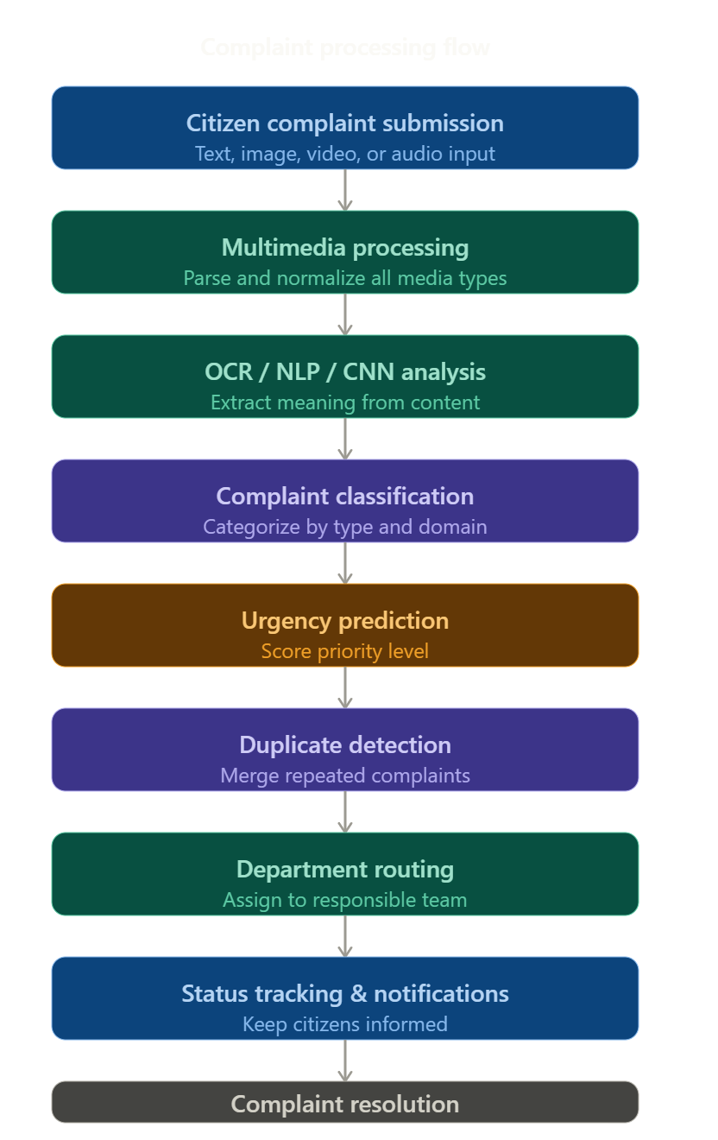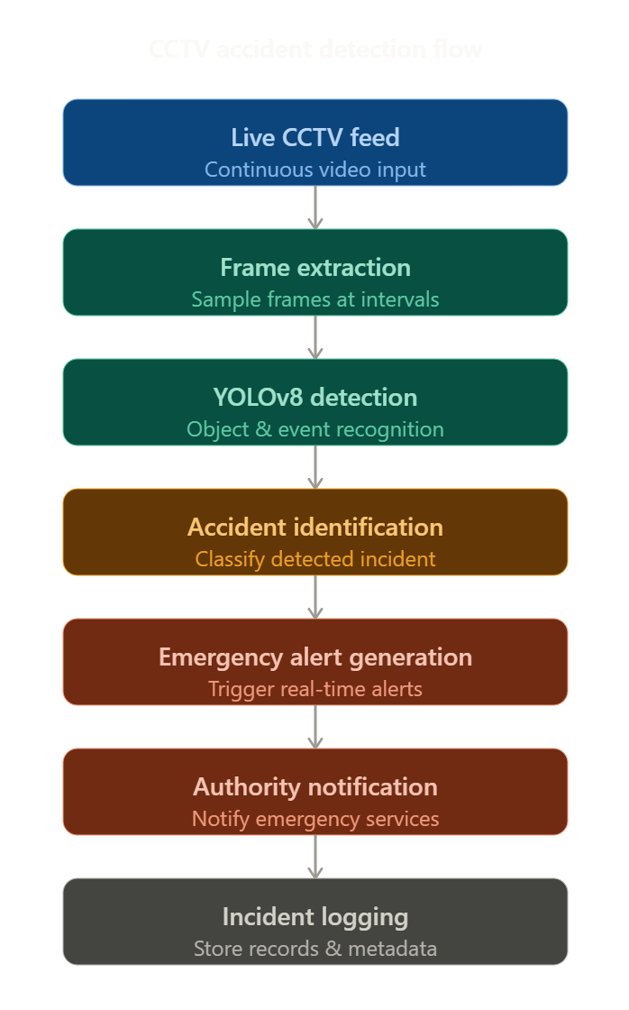

Dataset Description

1. Civic Issue Dataset

Description

This dataset contains images and complaint descriptions related to common civic problems such as:
- Potholes
- Garbage accumulation
- Water leakage
- Broken streetlights
- Damaged roads
- Traffic obstruction

Dataset Features
- Image data
- Text complaints
- GPS coordinates
- Timestamp information
- Complaint category labels

Purpose

Used for training CNN and NLP models for complaint classification and severity prediction.

2. CCTV Accident Dataset

Description

Contains traffic surveillance videos and accident footage collected from public datasets and online surveillance sources.

Dataset Features
- Video frames
- Accident labels
- Vehicle movement data
- Collision events
- Time-based sequences

Purpose

Used for training YOLOv8-based accident detection models.

3. Text Complaint Dataset

Description

Contains multilingual civic complaint texts collected from public complaint portals and synthetic datasets.

Dataset Features
- Complaint text
- Language labels
- Issue category
- Urgency keywords

Purpose

Used for Natural Language Processing and complaint categorization.

4. Geo-location Dataset

Description

Stores latitude and longitude information for mapping civic issues.

Dataset Features
- GPS coordinates
- Area name
- Complaint density
- Department mapping

Purpose

Used for heatmaps, routing, and duplicate complaint detection.

Initial Prototype Demonstration

Prototype Features Implemented

The initial prototype of Shinrai demonstrates the core functionality of the proposed system.

Features Included
- User registration and login
- Complaint submission interface
- Image and video upload support
- GPS-based location tagging
- Complaint categorization
- Dashboard for authorities
- Complaint status tracking
- Notification module
- Initial AI classification workflow

Prototype Workflow
- Citizen logs into the application.
- User uploads complaint details.
- System processes complaint using AI modules.
- Complaint is categorized and stored.
- Authority dashboard displays issue.
- User receives status updates.

Technologies Used in Prototype

Frontend
- React Native
- HTML/CSS
- JavaScript

Backend
- Node.js
- Express.js

Database
- MongoDB

AI/ML
- Python
- TensorFlow
- OpenCV
- YOLOv8

Cloud Services
- Azure Cloud

Achievement of Objectives as per Plan

Objectives Achieved

1. Multimedia Complaint Reporting

Successfully designed interfaces for image, text, video, and voice-based complaint reporting.

2. GPS-Based Geo-tagging

Implemented location tagging for accurate issue mapping.

3. AI-Based Complaint Classification

Developed initial workflows for AI-driven complaint categorization.

4. Duplicate Detection Logic

Designed SBERT-based similarity matching approach.

5. Automated Routing

Planned department-wise routing architecture.

6. Real-Time Notifications

Integrated notification framework for citizen updates.

7. Governance Dashboard

Designed dashboards with complaint monitoring features.

8. CCTV-Based Accident Detection

Planned YOLOv8 integration for surveillance monitoring.

Pending Enhancements
- Large-scale dataset training
- Real-time deployment optimization
- Advanced multilingual NLP support
- Performance evaluation and testing
- Edge-device optimization for CCTV systems

Prototype Screenshots:

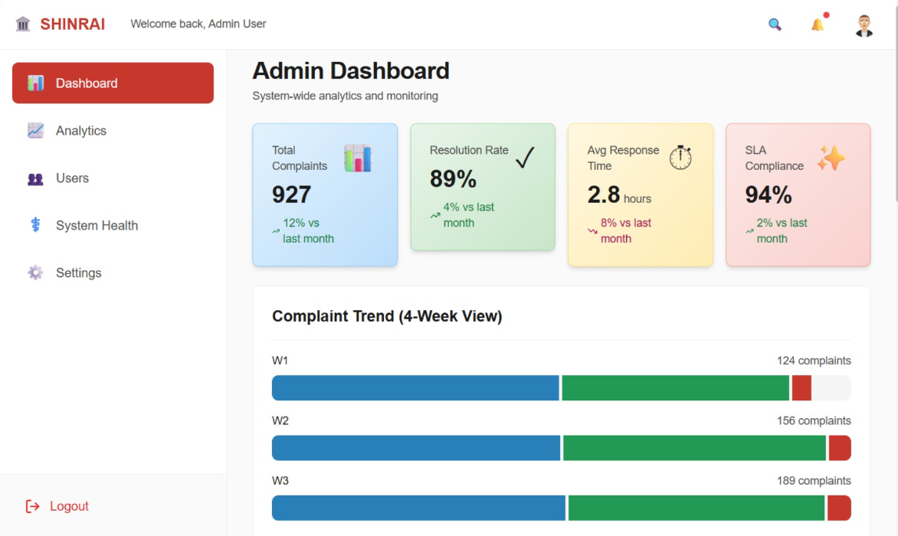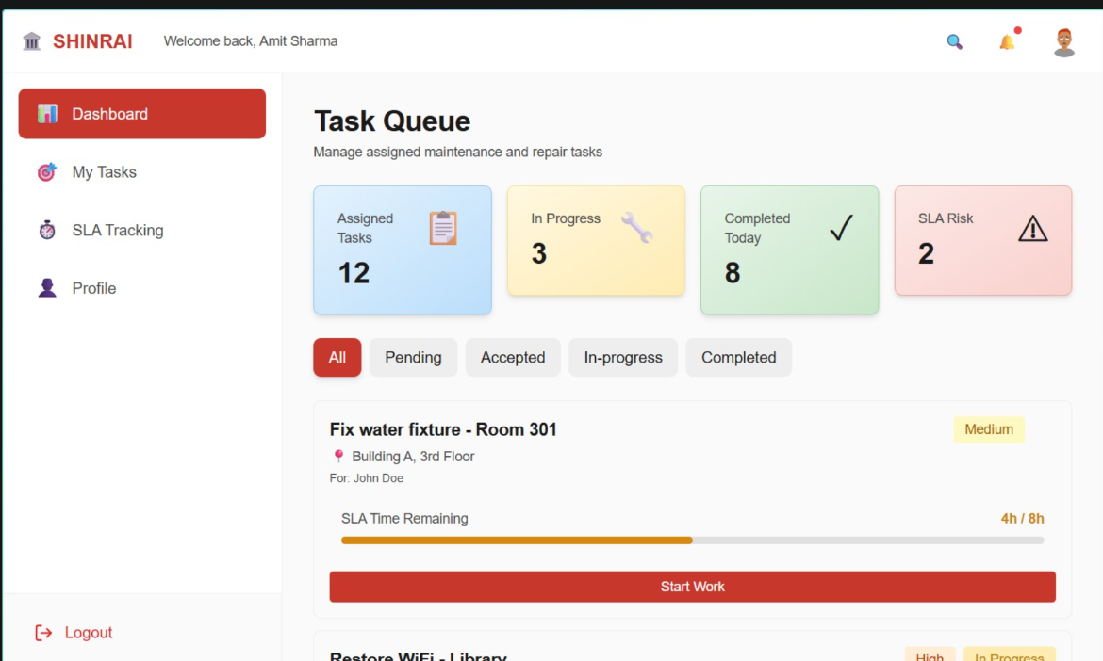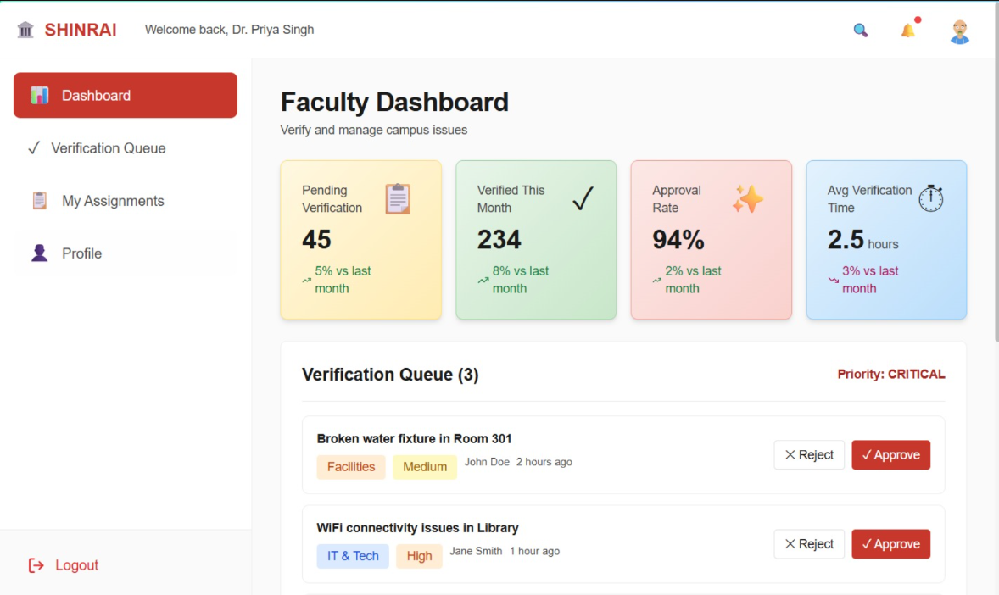

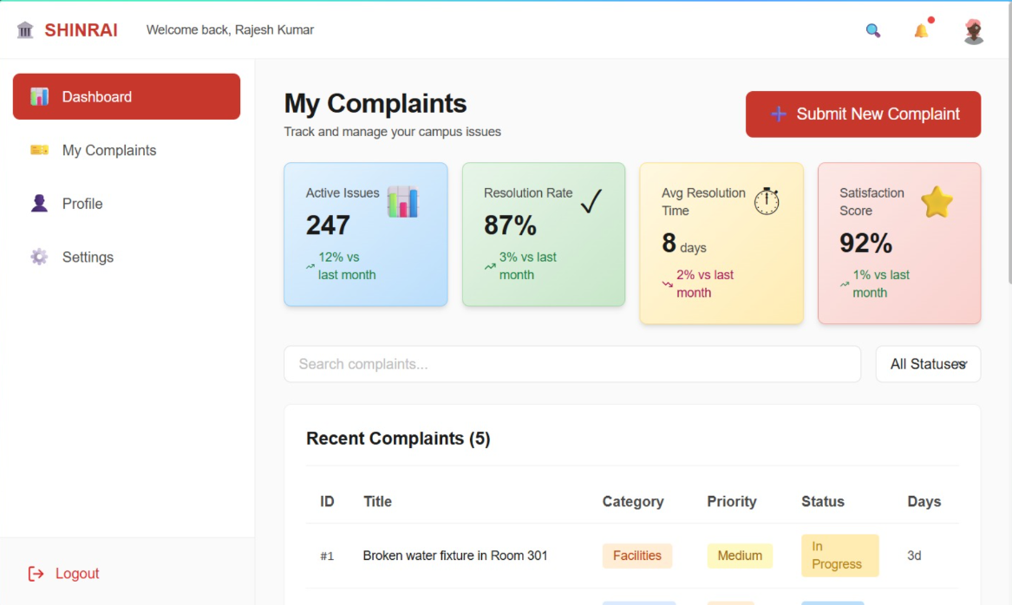

4. Project Planning

Gantt Chart
Phase | Task | Timeline
Phase 1 | Requirement Analysis | Week 1–4
Phase 2 | Literature Review | Week 4–8
Phase 3 | System Design | Week 8–12
Phase 4 | Frontend Development | Week 12–18
Phase 5 | Backend Development | Week 18–22
Phase 6 | AI Model Development | Week 22–28
Phase 7 | CCTV Module Integration | Week 28–32
Phase 8 | Testing & Deployment | Week 32–36

Team Contribution
Team Member | Contribution
Harshita Singh | Research work, documentation, UI planning
K. Shreeshanth | Backend APIs and database management
Piyush Sharma | AI/ML models and accident detection
Poorna Chandra | Frontend and dashboard implementation
Purab Bhatia | Cloud deployment and integration
Rajat Kar | Literature review and testing

Work Breakdown Structure

Phase 1 – Research & Analysis
- Problem identification
- Requirement gathering
- Literature survey

Phase 2 – System Design
- Wireframes
- Database schema
- System architecture

Phase 3 – Development
- Frontend module
- Backend module
- Authentication system

Phase 4 – AI Integration
- Complaint classification
- NLP pipeline
- Urgency prediction

Phase 5 – CCTV Integration
- Video analysis
- YOLOv8 implementation
- Alert system

Phase 6 – Deployment & Testing
- Unit testing
- Integration testing
- Cloud deployment
- Documentation

5. Conclusion and Future Directions

Conclusion

Shinrai is an AI-powered civic issue reporting and resolution system designed to improve communication between citizens and governing authorities. The platform combines crowdsourcing, Artificial Intelligence, Computer Vision, and smart governance technologies to create an efficient and transparent complaint management ecosystem.

The system enables citizens to report issues using multimedia inputs and provides automated complaint classification, urgency prediction, duplicate detection, and department routing. The integration of CCTV-based accident detection further enhances public safety by enabling proactive emergency response.

By improving transparency, accountability, and operational efficiency, Shinrai contributes toward the development of smarter and safer cities.

Future Directions

The project can be further enhanced through:
- Integration of Large Language Models (LLMs)
- Advanced multilingual support
- Blockchain-based complaint verification
- IoT sensor integration
- Predictive analytics for recurring issues
- Mobile app optimization
- Smart traffic management integration
- Edge AI deployment for CCTV systems

6. References
- Sandeep G. Shukla et al., “Civic Complaint Registration Application for Citizens of Urban/Rural Areas,” Journal of Emerging Technologies and Innovative Research, 2024.
- “A Theoretical Framework for AI-Assisted Civic Issue Reporting and Validation in Smart Cities,” IJERT, 2026.
- C. Ashwitha and K. Vani, “Smart Civic Complaint Analyzer Using NLP,” International Journal of Innovative Research in Technology, 2025.
- Dnyanesh Walwadkar et al., “Smart Civic Issue Reporting System,” IJARSCT, 2022.
- Nikila Annela and T. Naga Nishith, “Real-Time Accident Detection Leveraging Deep Learning for Enhanced Road Safety,” IJERT.
- Official documentation of: YOLOv8, TensorFlow, OpenCV, React Native, Azure Cloud Services

